10.12: a) The cylinder does not move, so the net force must be zero. The cable exerts a horizontal force to the right, and gravity exerts a downward force, so the normal force must exert a force up and to the left, as shown in Fig. (10.9).
b) 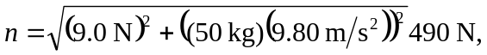at an angle of arctan 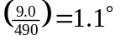 from the vertical (the weight is much larger than the applied force F ).

